# CPT_Logo_Manual.jpg Adding Content Pages to Sites

**Lab Time**: 60 minutes

**Lab Overview:** In this lab you will practice implementing web part pages in a SharePoint site. You will also learn to connect web parts on a page and audience target a web part.

## Exercise 1: Creating a Web Part Page

In this exercise you will practice creating a web part page.

1. Log into your site collection using the account **Rob Walters**, a member of the Site Owners group with Full Control permissions to the site.
2. Using Internet Explorer, browse to the URL of the SharePoint site collection you were provided to use when working on the hands on labs in this course.
3. When prompted to login, enter [[AD-DOMAIN]]\rob in the **User Name** field and click **OK**. Use the password specified in the *Hands-On Lab Overview* document provided in the student manual.
4. Create a new subsite under your lab site in the site collection hierarchy with the following property values (skills for this step were learned in the previous module of this course):

**Site Template:** Team Site

**Title:** Web Part Page Lab Site

**Description:** Site created for performing site and Web Part Page content lab.

**Site URL:** WebPartPageLab

**Permission Inheritance:** Use same permissions as parent site

1. Populate the new site's Announcements list:
2. Click the **Lists** heading in the Quick Launch Bar and click the **Announcements** list from the resulting page.
3. Click the **Add new announcement** link to create four new announcements as follows:

|  |  |  |
| --- | --- | --- |
| **Title** | **Body** | **Expires** |
| New COO announced | Type a few lines | Friday following today's date |
| Corporate holiday party | Type a few lines | Two weeks from today's date |
| National Toy-makers Association Conference | Type a few lines | Two weeks from today's date |
| New recognition program | Type a few lines | Friday following today's date |

1. Return to the home page of the Web Part Page Lab Site via your preferred method.
2. Populate the new site's **Calendar** list:
3. Navigate to the **Calendar** list by clicking the list's link in the Quick Launch Bar.
4. Click the **New Event** link then the **New** group of the **Calendar Events »** **Events** tab in the ribbon and add at least three new events of your discretion to the calendar (use the same near future date in the Start Time values on two of the three events).
5. Populate the new site's **Site Assets** library:
6. Navigate to the Site Assets library by clicking the **Libraries** header in the Quick Launch Bar then clicking the **Site Assets** library name under the Libraries heading.
7. Use Microsoft Word, Excel or Notepad to create a new document, spreadsheet or text file and save it to your desktop.
8. Find a few pictures on your workstation or download them off the internet and save them to your desktop.

**Note**: Can’t find any pictures? Grab a few pictures of cars from Wikipedia: http://www.wikipedia.com.

1. Click the **Add document** link then the **Upload Multiple Files...** hyperlink to upload the picture files you found and document file from desktop on your workstation.
2. Create a new Web Part Page into the new site:
3. Click the **All Site Content** link in the Quick Launch Bar then click the **Create** link in the toolbar.
4. In the resulting **Create** pop-up window scroll down to the bottom of the template listing and click on the **Web Part Page** button to select the template and click the **Create** button.

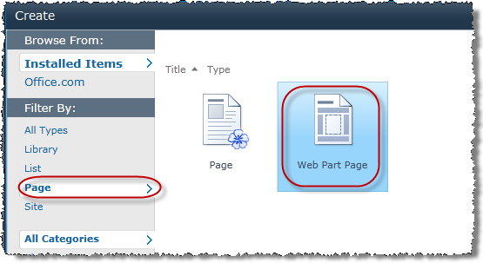

1. On the automatically loaded **New Web Part Page** Web page enter the following values for your new Web Part page, taking the time to scroll through each of the page layout choices to see the preview of each:

**Name:** labwppage

**Layout Template:** Header, Left Column, Body

**Document Library:** Site Assets

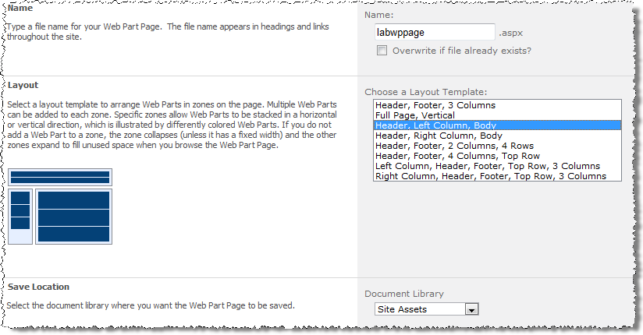

1. Click **Create** to finish creating the new Web Part page.
2. Once automatically navigated to the new Web Part page, verify it appears as an item in the **Site Assets** library by looking at the URL:



1. With the page created, add some content to the page:
2. With the page in edit mode, you should now see the Web Part zones available on the page to house Web Parts. These zones are courtesy of the page layout chosen during page creation. Click the **Add a Web Part** hyperlink in the **Header** zone.

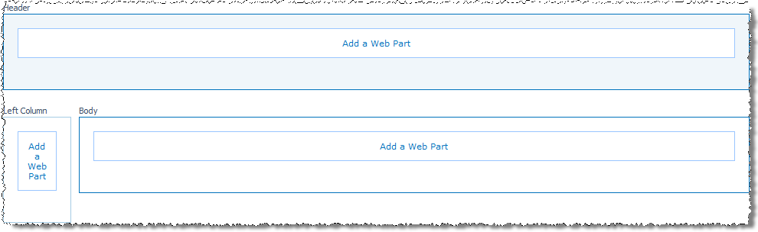

1. In the **Categories** pane of the Web Part insert section that appears at the top of the page click to select the **Media and Content** category then click to select the **Content Editor** Web Part and click the **Add** button to add the Web Part to the Header zone.

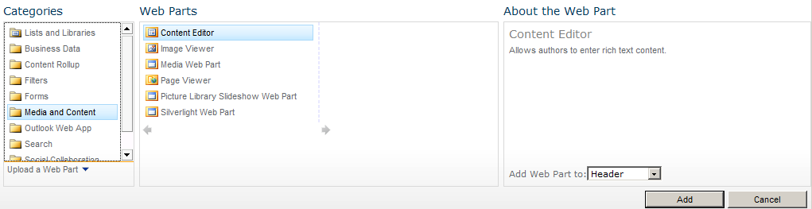

1. Click the **Click here to add new content** hyperlink now appearing in the new Content Editor Web Part in the Header zone and type the following text into the Web Part: **Welcome to the Web Part Lab Web Part Page!**

M3_Lab06.png

1. With the page still in edit mode, click the **Add a Web Part** hyperlink in the **Left Column** zone.
2. In the **Categories** pane of the Web Part insert section that appears at the top of the page click to select the **Media and Content** category then click to select the **Image Viewer** Web Part and click the **Add** button to add the Web Part to the **Header** zone.
3. Click the **open the tool pane** hyperlink in the description of the newly inserted **Image Viewer Web Part** to open the Web Part's configuration pane.

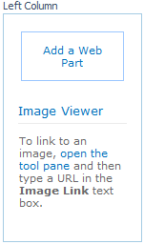

1. In the **Image Link** field of the **Image** section at the top of the **Image Viewer Web Part's** tool pane, enter the URL of one of the pictures you uploaded to the Site Assets library to configure the Web Part to display an image file.

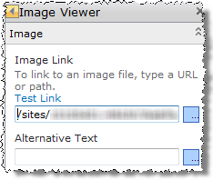

1. Expand the **Appearance** section of the tool pane and change the **Title** field value to **Toys**.
2. Scroll down the **Appearance** section and Read the options available before changing the **Chrome Type** to **Title Only**.
3. Expand the **Layout** section. Read the options available but DO NOT alter any of them. Hover your mouse pointer over the **Zone Index** field title and wait until a tool tip pops up describing the purpose of the setting.

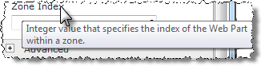

1. Expand the **Advanced** section. **Clear** the **Allow Close** option. Read the other options available taking particular notice of the **Target Audiences** field at the bottom (this will come into play in another exercise in this lab).
2. Click **OK** at the bottom of the tool pane to save your configuration changes to the Web Part.
3. If the **Page Tools** contextual tab disappeared when the Web Part tool pane disappeared, click the **Page** tab. The page is still in edit mode, it just needs to receive focus again.
4. Open the **Insert** tabin the **Page Tools** contextual tab group in the ribbon on the page while you still have the page in edit mode. These buttons will add corresponding Web Parts to whichever zone you have your cursor positioned in before clicking the button. The **Text** button adds a Content Editor Web Part, the **Image** button adds an Image Viewer Web Part, the **Video and Audio** button adds a Media Web Part and the **Existing List** button adds a list's Web Part of your choosing. Just another way to add commonly used Web Parts!

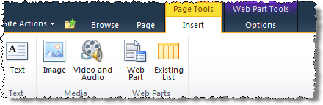

1. Use your newly acquired skills to add both the **Calendar** list Web Part and the **Announcements** list Web Part (in any order) to the **Body** zone of the Web Part page then save your changes to the page by clicking the **Stop Editing** button in the **Edit** group of the **Page** tab in the ribbon. *Hint: they are in the* ***Lists and Libraries*** *category when adding Web Parts.*

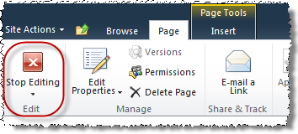

1. Notice the default view of the Calendar list was selected as the view for the Calendar Web Part on the page. Alter the Web Part to present a more concise view of the Calendar list:
2. Click the drop-down arrow on the right edge of the **Calendar** list Web Part's title bar and choose **Edit Web Part** from the resulting contextual menu.

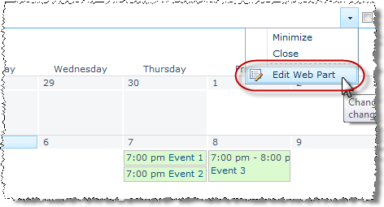

1. In the Calendar Web Part's configuration (tool) pane, change the **Selected View** field in the **List Views** section from **<Current view>** to the **All Events** view. Read the pop-up warning then click **OK** to close it.

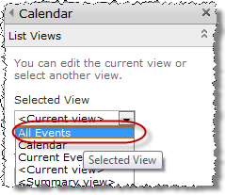

1. Take a moment to examine the changes you’ve made to the Web Part page:

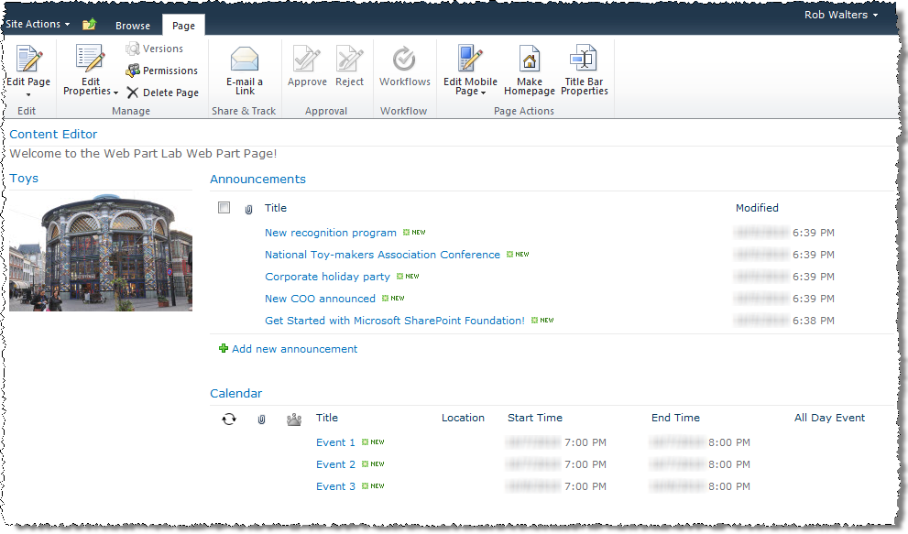

In this exercise you learned to add and populate a Web Part page in a SharePoint site.

## Exercise 2: Connecting Web Parts

In this exercise you will practice connecting Web Parts on a Web Part page.

1. Use your newly acquired skills from the previous exercise to add a **Date Filter** Web Part (found in the **Filters** category) to the **Body** Web Part zone of the **Lab Web Part Page** you created in the previous exercise.
2. Configure the new **Date Filter** Web Part as a **Provider** in a connection relationship with the existing Calendar list Web Part on the page:
3. While in Edit mode, click the drop-down arrow on the right edge of the **Date Filter Web Part's** title bar and choose **Connections** from the resulting contextual menu then click **Send Filter Values To** and choose the **Calendar** list Web Part from this page:

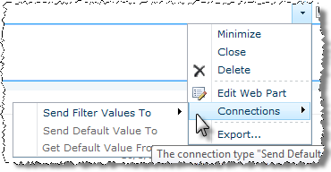

**Note**: If you receive an Internet Explorer security warning banner across the top of the page indicating that Internet Explorer's pop-up blocker has blocked a pop-up, click the warning banner and choose to **Always allow Pop-Ups**. This may cause the page to refresh in which case you will need to repeat the previous step.

1. In the **Choose Connection** dialog, notice that you are selecting the connection type for the **Consumer (Calendar)**, not the Provider. Leave the default value in the field and click **Configure**.

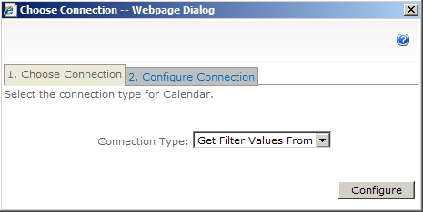

1. In the **Choose Connection** dialog, use the drop-down menu of the **Consumer Field Name** field to select **Start Time** then click **Finish** to complete the connection.

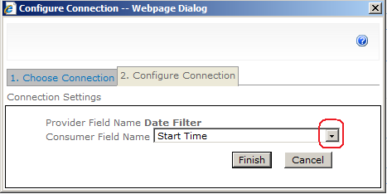

1. Verify that the connection is in place by noting the new message that appears on the Date Filter Web Part just beneath the Web Part title:

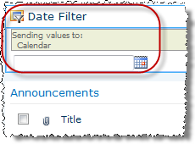

1. Save your changes to the page by clicking the **Stop Editing** button in the *Edit* section of the Page ribbon. Remain on the page for the next step.
2. Test the new Web Part connection between the Date Filter Web Part and the Calendar list Web Part:
3. Make note of the start dates of each of the events in the Calendar list Web Part.
4. Enter one of the start dates noted above in Date Filter Web Part and press [ENTER].
5. Notice the Calendar Web Part filters the items displayed to only those items matching your desired date entered into the Date Filter Web Part.
6. Notice also the funnel icon on the **Start Time** column name in the Calendar list Web Part indicating the Web Part is being filtered according to the values in this column.

M3_Lab17.png

1. Enter a different start date of another **Calendar** item in the **Date Filter** Web Part and press [ENTER]. Notice the Calendar Web Part adjusts to the new date desired.
2. Remove the date filter from the **Calendar** list by removing the value from **Date Filter** Web Part and press [ENTER].

In this exercise you learned to connect two Web Parts.

## Exercise 3: Apply Audience Targeting a Web Part

In this exercise you will learn to target a Web Part toward a specific audience.

1. Enable audience targeting on the Announcements list Web Part in the Body zone:
2. Click the drop-down arrow on the right edge of the **Announcements** list Web Part's title bar and choose **Edit Web Part** from the resulting contextual menu to open the Web Part's tool pane.
3. Collapse the **List Views** section and expand the **Advanced** section. Scroll to the bottom of the **Advanced** section and click the **Browse** icon in the lower right corner below the **Target Audiences** field.

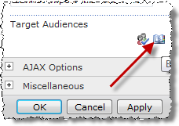

1. In the resulting **Select Audiences** dialog, use the drop down menu of the **Find** field to change the source to **SharePoint Groups**. Type **Vie** into the **Find** field and click the magnifying glass button. All SharePoint groups having names that start with **Vie** will appear in the results pane. Single-click to highlight **Viewers** and click the **Add->** button below the results pane to add **Viewers** to the list of objects chosen from the find results. Click **OK** to add the **Viewers SharePoint** group as a target audience for the Web Part.

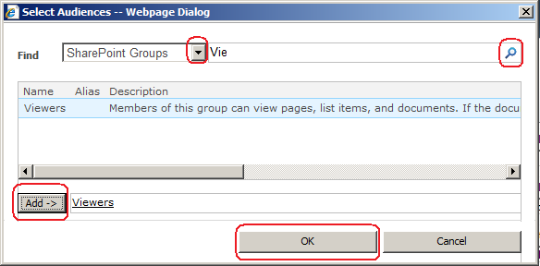

1. Verify that the **Viewers** SharePoint group appears in the **Target Audiences** field of the **Advanced** section in the **Announcements** list Web Part's tool pane.

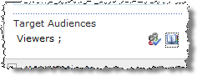

1. Click **OK** to close the tool pane to save your changes to the Web Part.
2. Test the audience targeting on the Announcements Web Part:
3. Authenticate into the library as Mike Sullivan using the **Welcome Menu** in the top right corner and select **Sign in as Different User** and enter [[AD-DOMAIN]]\michael for the user name and click **OK**.
4. Verify that the Announcements list Web Part does not appear in the Body zone of the page for Michael because he is not a member of the **Viewers** SharePoint group.

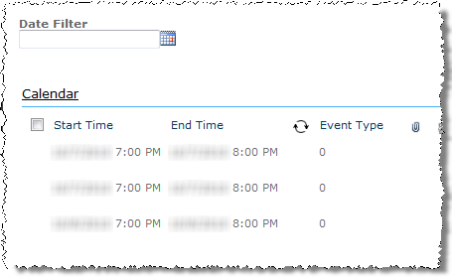

1. Authenticate into the library as Rob Walters using the **Welcome Menu** in the top right corner and select **Sign in as Different User** and enter [[AD-DOMAIN]]\robw for the user name and click **OK**.
2. Verify that the **Announcements** list Web Part no longer appears in the **Body** zone of the page for Rob because Rob is not a member of the Viewers SharePoint group, even though Rob has Full Control to the page!



In this exercise you practiced audience targeting.